**PRACTICAL NO-7**

**Aim : Write a program for web feed (RSS - Really Simple Syndication)**

**Steps:**

1. **Install RSS Builder**
2. **Create a RSS Builder file with “.xml” extensions and save it.**
3. **Open Visual Studio and create an empty web site -> add reference of “RSS Builder file”.**
4. **Copy your RSS file in your websites package.**
5. **Add RSS Feed Reader Extension in Google Chrome.**

**Input :-**

<%@ Page Language="C#" AutoEventWireup="true" CodeFile="Default.aspx.cs" Inherits="_Default" %>

<!DOCTYPE html>

<html xmlns="http://www.w3.org/1999/xhtml">

<head runat="server">

<title></title>

</head>

<body>

<form id="form1" runat="server">

<div>

<p> Here is your <a href="mywidget.xml">Feed</a></p>

</div>

</form>

</body>

</html>

**RSS Builder : Fill any details -> save as “.xml”**

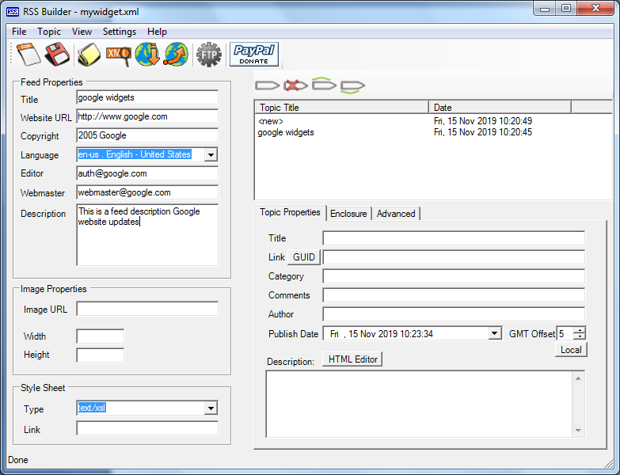

**Output :-**

**After Clicking on Feed.**



